Midterm Project
For this assignment you will develop a multi-page functional website that covers all topics learned until this point of the course. The website will be structured in the following way:

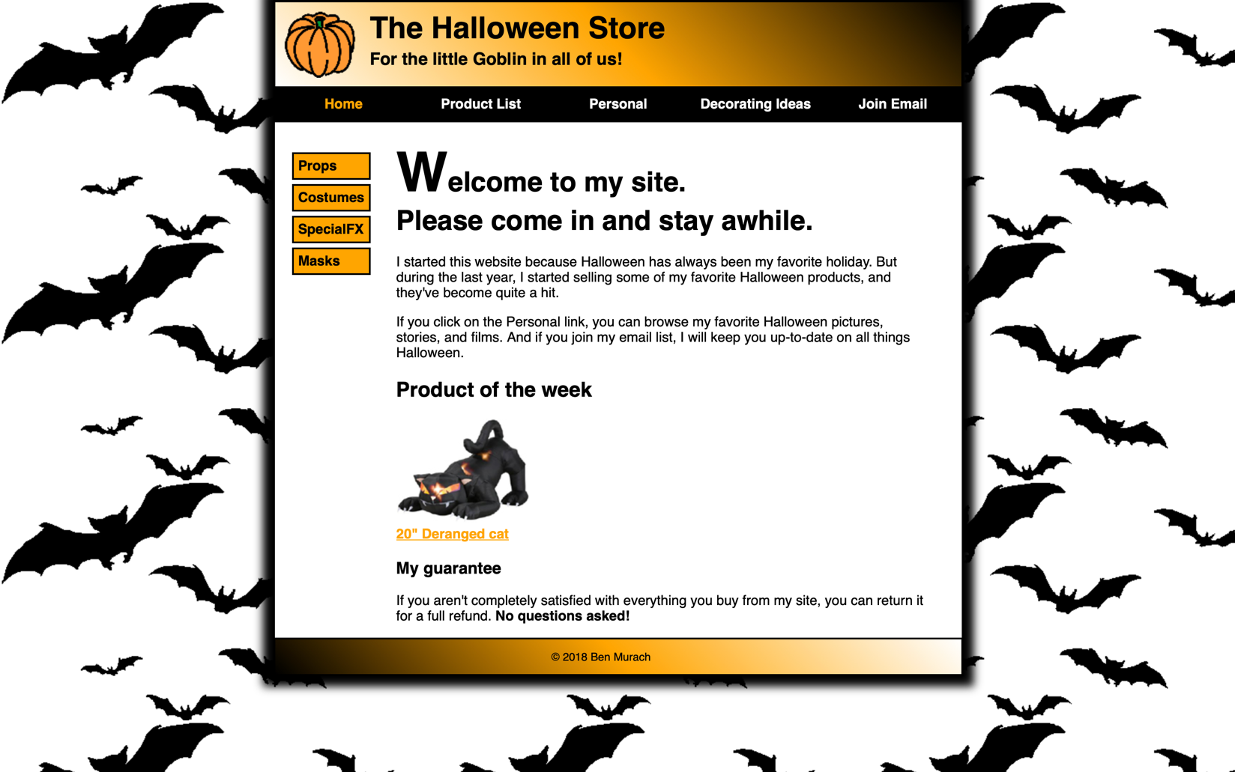
- Home.html

Requirements:
-Apply all the needed CSS formatting to make it look as close as possible to the example image.
-The “Home” element of the navigation menu of the header must be orange since it is the current page.
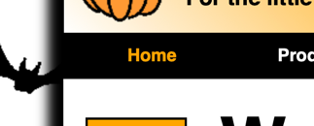
- Regarding the navigation menu of the header, when clicking on “Product List” the site must re-direct you to Products.html. The rest of the elements of the menu don’t need to have working links.
-Hovering the cursor on any of the navigation menu elements of the header must change their background color to gray.
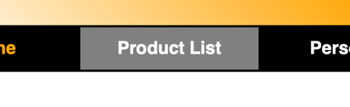
-Hovering on the “Decorating Ideas” element of the navigation menu must display a submenu that is hidden by default. The submenu looks like the following:
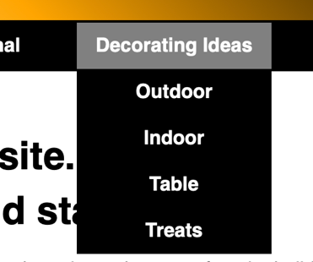
-Use gradient colors for the background of Header and footer of the page
-Use shadows for the outer part of the main body of the page
-The orange menu on the left part of the body is also a navigation menu of clickable links. They don’t need to have working links, but they must change to color Green if hovered with the mouse.
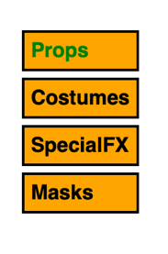
-The link for the 20” Deranged cat must change to color Green when hovered, and re-direct you to Cat.html
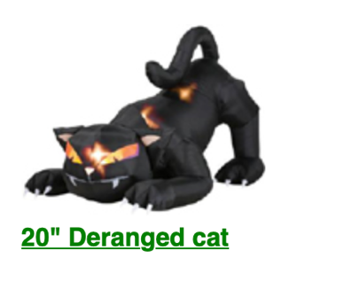
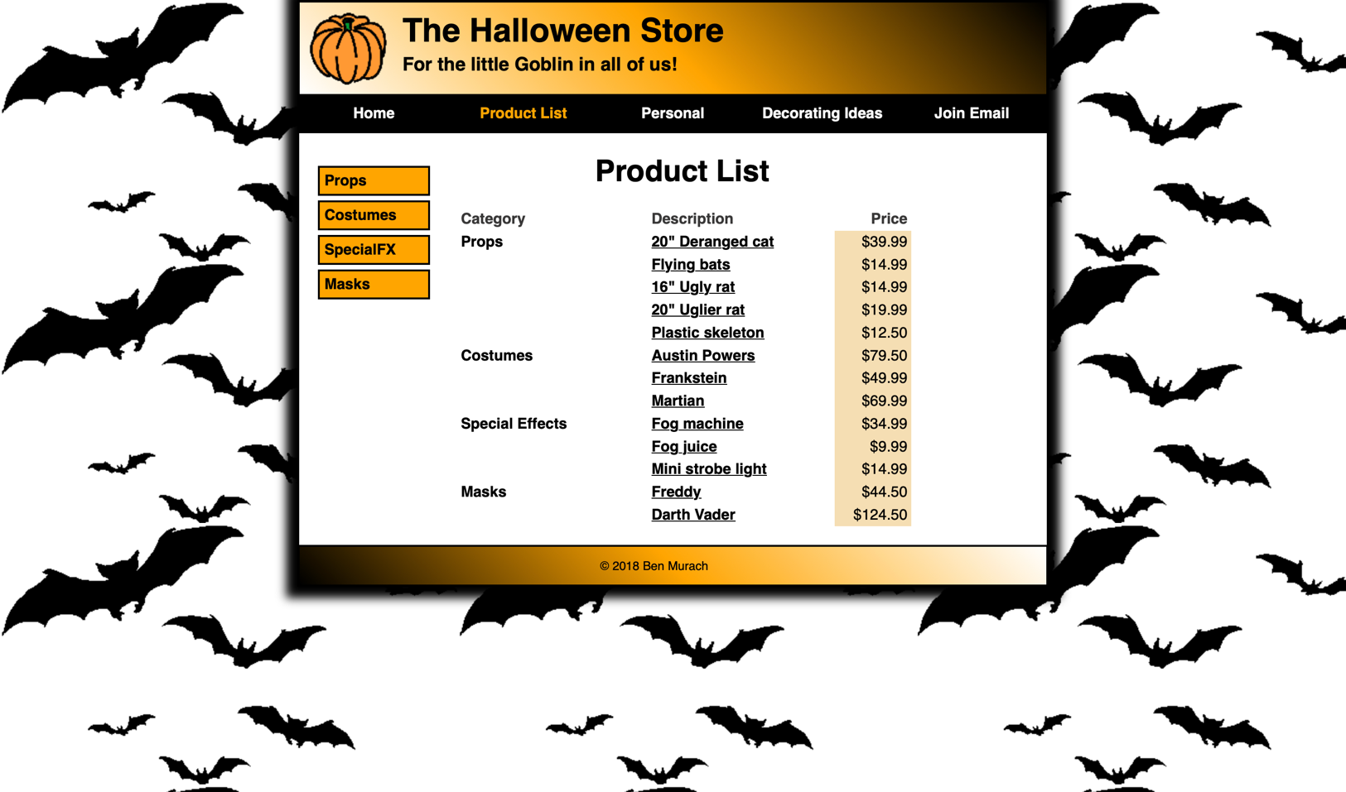
- Products.html

Requirements:
-Apply all the needed CSS formatting to make it look as close as possible to the example image.
-The “Product List” element of the navigation menu of the header must be orange since it is the current page.

- Regarding the navigation menu of the header, when clicking on “Home” the site must re-direct you to Home.html. The rest of the elements of the menu don’t need to have working links.
-Create a table for the Product List with the same formatting as the picture. For the description column, each of the values are clickable links although they don’t need to actually re-direct you to other pages. The only exception will be 20” Deranged cat which must re-direct you to Cat.html
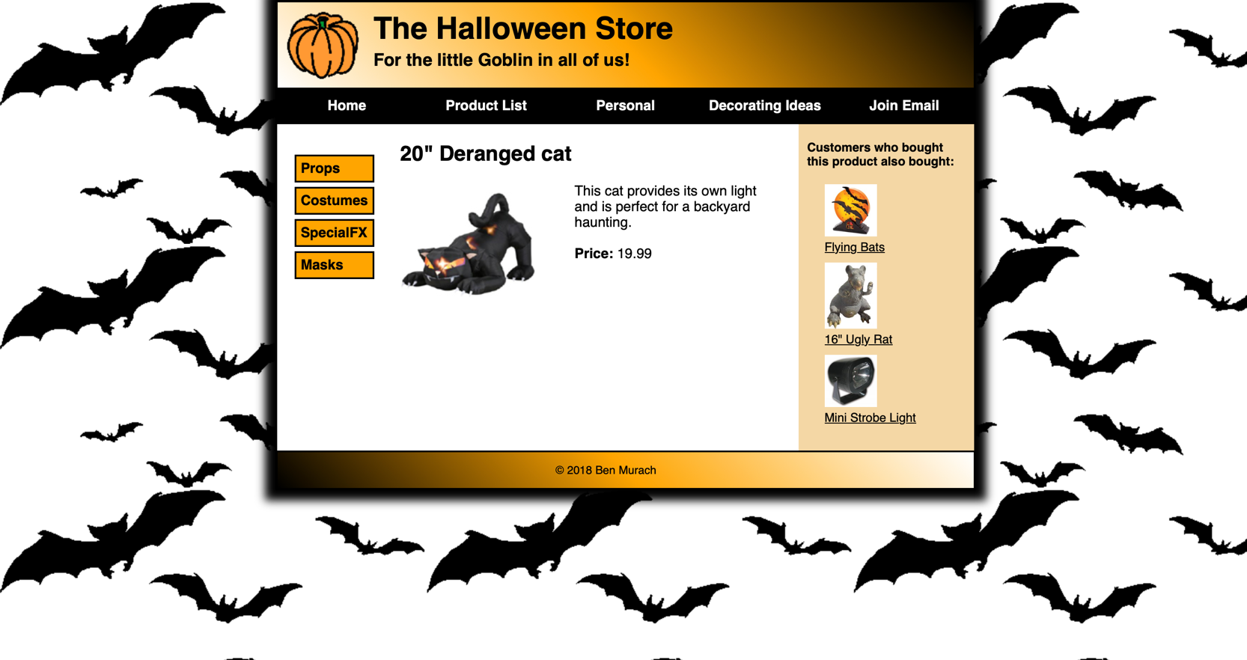
- Cat.html

Requirements:
- Apply all the needed CSS formatting to make it look as close as possible to the example image.
- For the products on the right side, each name must be a clickable link that changes to color Green when hovered.
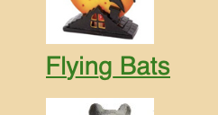

Final Note:
-The title of all the web pages must be “Halloween Store” and have the Pumpkin favicon as the icon next to it.


